Exercised
Note: Use Java keywords and concepts in problem solving.
1. Create Java classes having suitable attributes for Library management system.Use OOPs concepts in your design.Also try to use interfaces and abstract classes.
//Library Management System directory is attached
2. WAP to sorting string without using string Methods?.
public class Sorting {
String sort(String string)
{
char ch[]=string.toCharArray();
int len=ch.length;
/*
//to trim the char array
for(int i=0;i<len;i++)
{
if(ch[i]==' ')
{
for(int j=i;j<len-1;j++)
ch[j]=ch[j+1];
len--;
i--;
}
}
*/
for(int i=0;i<len-1;i++)
{
for(int j=i+1;j<len;j++)
{
if(ch[i]>ch[j])
{
char temp=ch[i];
ch[i]=ch[j];
ch[j]=temp;
}
}
}
///returning string
return String.valueOf(ch);
}
public static void main(String[] args) {
String string = "welcome";
String sortedString=new Sorting().sort(string);
System.out.println("Sorted string= "+sortedString);
}
}

Output:
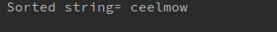

3. WAP to produce NoClassDefFoundError and ClassNotFoundException exception.
//WAP to produce ClassNotFoundException exception.
public class Assign2 {

public static void main(String[] args) {
try{
Class.forName("com.SampleJavaPro.A");
}
catch (Exception e)
{
e.printStackTrace();
}
}
}
Output:
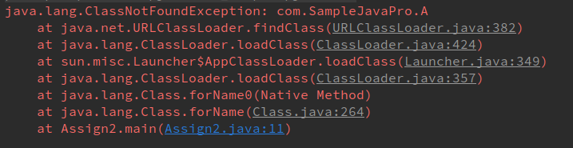
//WAP to produce NoClassDefFoundError exception.
public class Test {
private int data;
public int getData() {
return data;
}
public void setData(int data) {
this.data = data;
}
}
public class Assign2 {
public static void main(String[] args) {
Test test=new Test();
System.out.println(test.getData());
}
}
Output:
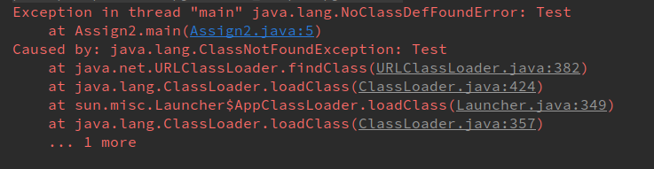

4. WAP to create singleton class.
public class Assign2 {
public static void main(String[] args) {
SingletonExample singletonExample1=SingletonExample.getInstance();
SingletonExample singletonExample2=SingletonExample.getInstance();
System.out.println("first object reference= "+singletonExample1);
System.out.println("second object reference= "+singletonExample2);
}
}
class SingletonExample{
private static SingletonExample singletonExample;
static {
singletonExample=new SingletonExample();
}
private SingletonExample() {
}
public static SingletonExample getInstance(){
return singletonExample;
}
}

Output:

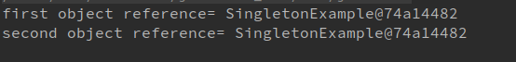

5. WAP to show object cloning in java using cloneable and copy constructor both.
//using cloneable interface
public class Assign2 implements Cloneable {
String firstName;
int age;
public Assign2(String firstName, int age) {
this.firstName = firstName;
this.age = age;
}
public Object clone() throws CloneNotSupportedException{
return super.clone();
}
public static void main(String[] args) throws CloneNotSupportedException {
Assign2 assign2=new Assign2("Amarjeet",21);
Assign2 assign21=(Assign2)assign2.clone();
System.out.println("first object:");
System.out.println("first name: "+assign2.firstName);
System.out.println("age: "+assign2.age);
System.out.println("second object:");
System.out.println("first name: "+assign21.firstName);
System.out.println("age: "+assign21.age);
}
}
//using copy constructor

class Student {
String firstName;
int age;
public Student(String firstName, int age) {
this.firstName = firstName;
this.age = age;
}
public Student(Student student) {
this.firstName = new String(student.firstName);
this.age = student.age;
}
public static void main(String[] args) {
Student student=new Student("Amarjeet",21);
Student student1=new Student(student);
System.out.println("first object:");
System.out.println("first name: "+student.firstName);
System.out.println("age: "+student.age);
System.out.println("second object:");
System.out.println("first name: "+student1.firstName);
System.out.println("age: "+student1.age);
}
}
Output:
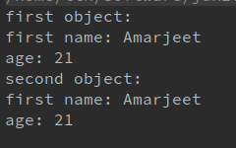
6. WAP showing try, multi-catch and finally blocks.
class ExceptionExample {
public static void main(String[] args) {
try {
System.out.println("try block start");
int num=10/0;
}
catch (ArithmeticException a){
System.out.println(a);
}
catch (Exception e){
System.out.println(e);
}
finally {
System.out.println("finally block");
}
}
}
Output:
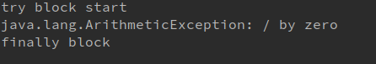

7. WAP to convert seconds into days, hours, minutes and seconds.
import java.util.Scanner;
class DateAndTimeExample{
public int calculateHoursFromSecond(int second) {
return second/(60*60);
}
public int calculateMinuteFromSecond(int second) {
return second/60;
}
public int calculateDaysFromSecond(int second) {
return second/(60*60*24);
}
public static void main(String[] args){
Scanner sc=new Scanner(System.in);
System.out.println("Enter second");
int second=sc.nextInt();
DateAndTimeExample dateAndTimeExample=new DateAndTimeExample();
System.out.println("hours= "+dateAndTimeExample.calculateHoursFromSecond(second));
System.out.println("minutes= "+dateAndTimeExample.calculateMinuteFromSecond(second));
System.out.println("days= "+dateAndTimeExample.calculateDaysFromSecond(second));
}
}
Output:
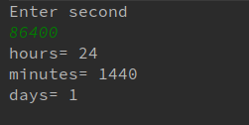

8. WAP to read words from the keyboard until the word done is entered. For each word except done, report whether its first character is equal to its last character. For the required loop, use a
a)while statement
b)do-while statement
//using while statement:
import java.util.Scanner;
class KeyboardTest{
public static void main(String[] args){
Scanner sc=new Scanner(System.in);
System.out.println("Enter any word: ");
String input=sc.nextLine();
while (!input.equals("done")) {
char ch[]=input.toCharArray();
if(ch[0]==ch[input.length()-1])
System.out.println("first character is equal to the character");
input = sc.nextLine();
}
}
}
//using do-while statement
import java.util.Scanner;
class KeyboardTest{
public static void main(String[] args){
Scanner sc=new Scanner(System.in);
System.out.println("Enter any word: ");
String input=sc.nextLine();
do{
char ch[]=input.toCharArray();
if(ch[0]==ch[input.length()-1])
System.out.println("first character is equal to the character");
input = sc.nextLine();
}while (!input.equals("done"));
}
}
Output:
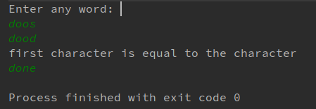

9. Design classes having attributes for furniture where there are wooden chairs and tables, metal chairs and tables. There are stress and fire tests for each products.
import java.util.Scanner;
interface Furniture {
void stressTest();
void fireTest();
}

abstract class Chair implements Furniture {
public abstract String chairType();
}

abstract class Table implements Furniture {
public abstract String tableType();
}

class MetalChair extends Chair {
@Override
public void stressTest() {
System.out.println("Failed Stress Test");
}
@Override
public void fireTest() {
System.out.println("Passed Fire Test");
}
@Override
public String chairType() {
return "metalchair";
}
}

class MetalTable extends Table {
@Override
public void stressTest() {
System.out.println("Passed Stress Test");
}
@Override
public void fireTest() {
System.out.println("Passed Fire Test");
}
@Override
public String tableType() {
return "metaltable";
}
}

class WoodenTable extends Table {
@Override
public void stressTest() {
System.out.println("Passed Stress Test");
}
@Override
public void fireTest() {
System.out.println("Failed Fire Test");
}
@Override
public String tableType() {
return "woodentable";
}
}

class WoodenChair extends Chair {
@Override
public void stressTest() {
System.out.println("Failed Fire Test");
}
@Override
public void fireTest() {
System.out.println("Failed Fire Test");
}
@Override
public String chairType() {
return "woodenchair";
}
}

public class Q9Furniture {
public static void main(String[] args) {
Table table;
Chair chair;
char choice;
Scanner input = new Scanner(System.in);
do {
System.out.println("Enter type of chair/table");
String str = input.next();
switch (str) {
case "woodenchair":
chair = new WoodenChair();
System.out.println(chair.chairType());
chair.stressTest();
chair.fireTest();
break;
case "metalchair":
chair = new MetalChair();
System.out.println(chair.chairType());
chair.stressTest();
chair.fireTest();
break;
case "woodentable":
table = new WoodenTable();
System.out.println(table.tableType());
table.stressTest();
table.fireTest();
break;
case "metaltable":
table = new MetalTable();
System.out.println(table.tableType());
table.stressTest();
table.fireTest();
break;
default:
System.out.println("enter valid input");
break;
}
System.out.println("do you want to continue?");
choice=input.next().charAt(0);
}while (choice=='y'||choice=='Y');
}
}
Output:
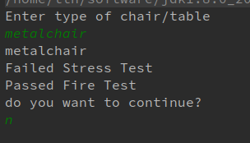

10. Design classes having attributes and method(only skeleton) for a coffee shop. There are three different actors in our scenario and i have listed the different actions they do also below
* Customer
- Pays the cash to the cashier and places his order, get a token number back
- Waits for the intimation that order for his token is ready
- Upon intimation/notification he collects the coffee and enjoys his drink
( Assumption: Customer waits till the coffee is done, he wont timeout and cancel the order. Customer always likes the drink served. Exceptions like he not liking his coffee, he getting wrong coffee are not considered to keep the design simple.)
* Cashier
- Takes an order and payment from the customer
- Upon payment, creates an order and places it into the order queue
- Intimates the customer that he has to wait for his token and gives him his token
( Assumption: Token returned to the customer is the order id. Order queue is unlimited. With a simple modification, we can design for a limited queue size)
* Barista
- Gets the next order from the queue
- Prepares the coffee
- Places the coffee in the completed order queue
- Places a notification that order for token is ready
//attached in the directory
11. Convert the following code so that it uses nested while statements instead of for statements:
int s = 0;
int t = 1;
for (int i = 0; i < 10; i++)
{
s = s + i;
for (int j = i; j > 0; j−−)
{
t = t * (j - i);
}
s = s * t;
System.out.println("T is " + t);
}
System.out.println("S is " + s);
import java.util.Scanner;
class Assign2{
public static void main(String[] args){
int s = 0;
int t = 1;
int i=0;
while (i < 10)
{
s = s + i;
int j = i;
while(j > 0)
{
t = t * (j - i);
j--;
}
s = s * t;
System.out.println("T is " + t);
i++;
}
System.out.println("S is " + s);
}
}

Output:
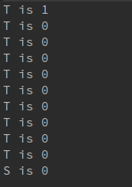

12.What will be the output on new Child(); ?
class Parent extends Grandparent {
{
System.out.println("instance - parent");
}
public Parent() {
System.out.println("constructor - parent");
}
static {
System.out.println("static - parent");
}
}
class Grandparent {
static {
System.out.println("static - grandparent");
}
{
System.out.println("instance - grandparent");
}
public Grandparent() {
System.out.println("constructor - grandparent");
}
}
class Child extends Parent {
public Child() {
System.out.println("constructor - child");
}
static {
System.out.println("static - child");
}
{
System.out.println("instance - child");
}
}
Output:
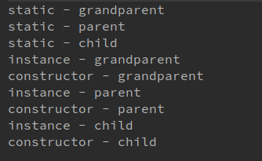

Q13. Create a custom exception that do not have any stack trace.
public class trry {
int id;
String Name;
int age;
trry(int id, String name, int a) throws AgeLessThan18Exception {
this.id = id;
this.Name = name;
if (a < 18)
throw new AgeLessThan18Exception("Less than 18");
else {
this.age = a;
}
}
public void setAge(int a) throws AgeLessThan18Exception {
if (a < 18)
throw new AgeLessThan18Exception("Less than 18");
else {
this.age = a;
System.out.println("Age is set to " + a);
}
}
}
class AgeLessThan18Exception extends Exception {
AgeLessThan18Exception(String excep) {
super(excep);
}
@Override
public void printStackTrace()
{
System.out.println("No stack trace msg");
}
}
class MainCaller {
public static void main(String[] args) {
try {
trry q1=new trry(1,"Amarjeet",12);
}
catch (Exception e) {
System.out.println(e);
e.printStackTrace();
}
}
}
Output:
